Excel Analysis Report
Financial Fraud Detection Using Credit Card Transactions

1. Statistical Summary of amt and city_pop
Objective
To understand the basic statistical characteristics of the transaction amount (amt) and city population (city_pop) variables before performing further analysis.
Analysis
Descriptive statistics were generated for both numerical variables using Excel's Descriptive Statistics tool. Measures such as mean, median, minimum, maximum, standard deviation, skewness, and kurtosis were analyzed to understand the distribution and variability of the data.

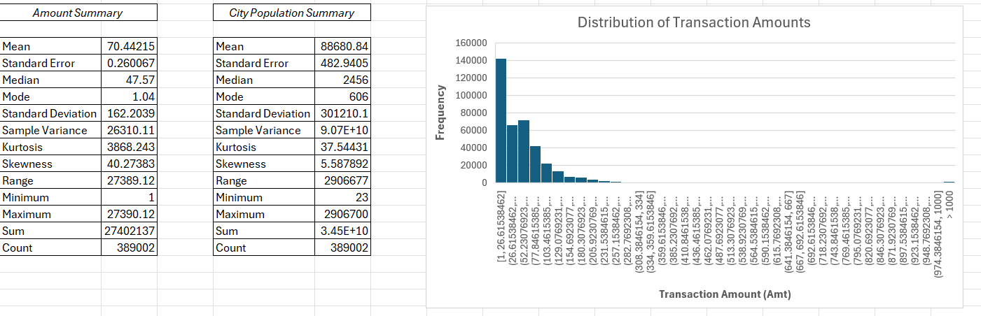

Key Findings
- The average transaction amount is 70.44, while the maximum transaction amount is 27,390.12, indicating the presence of high-value transactions.
- The transaction amount is highly positively skewed (Skewness = 40.27) with extremely high kurtosis, suggesting numerous outliers.
- The average city population is 88,680, with considerable variation across cities.
- The city_pop variable is also positively skewed, indicating that most transactions originate from smaller cities while only a few belong to highly populated
metropolitan areas.

2. Histogram of Transaction Amount (amt)
Objective
To visualize the distribution of transaction amounts and identify the presence of skewness and potential outliers.
Analysis
A histogram was created using transaction amount values with an overflow bin to improve readability.

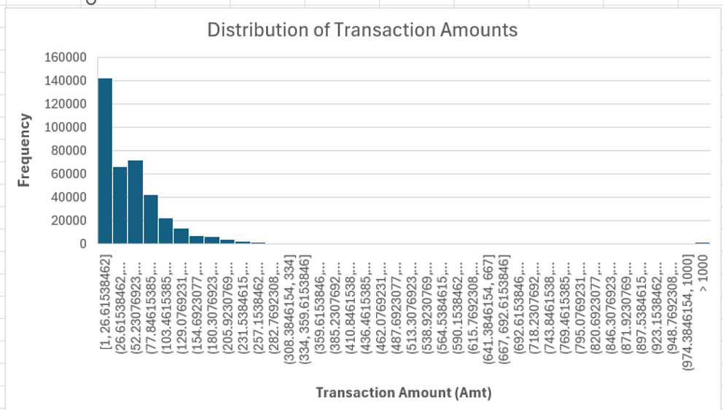

Key Findings
- Most transactions are concentrated in lower transaction ranges.
- The frequency decreases significantly as transaction amounts increase.
- The histogram exhibits a long right tail, confirming a highly right-skewed distribution.
- The presence of a few exceptionally large transactions indicates potential anomalies that may require further investigation.

3. Fraudulent Transactions by Gender and Category
Objective
To analyze fraudulent transactions across different customer genders and transaction categories.
Analysis
A Pivot Table and Pivot Chart were created by summing the is_fraud field grouped by Category and Gender.

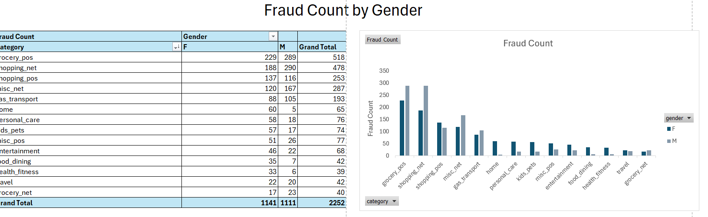

Key Findings
- Fraudulent transactions are distributed almost equally between male and female customers.
- The highest number of fraudulent transactions occurred in:
  - Grocery POS
  - Shopping Net
  - Misc Net
- Transaction category appears to have a stronger influence on fraud occurrence than customer gender.

4. Top 3 States by Number of Transactions
Objective
To identify the states generating the highest transaction volumes.
Analysis
A Pivot Table was created to count transactions by state and identify the top three states.

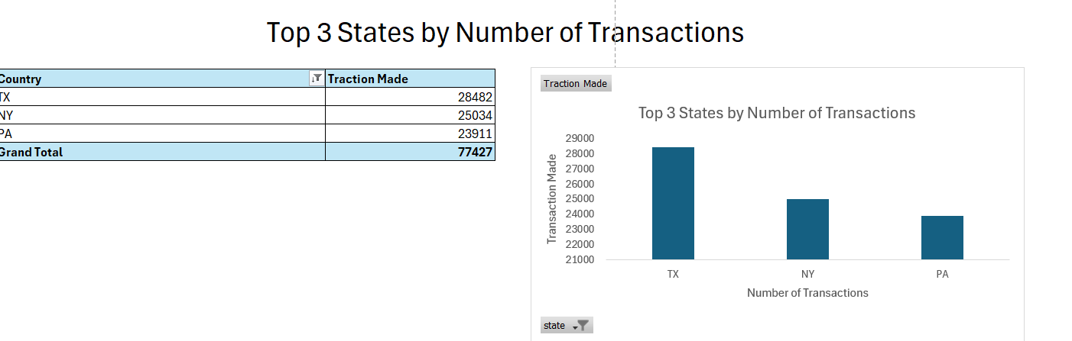

Key Findings
The three states with the highest number of transactions are:
Rank | State | Transactions
1 | Texas (TX) | 28,482
2 | New York (NY) | 25,034
3 | Pennsylvania (PA) | 23,911
These states account for a significant portion of the overall transaction volume and therefore require enhanced fraud monitoring.

5. Correlation Analysis (amt vs city_pop)
Objective
To determine whether city population influences transaction amount.
Analysis
The Excel CORREL() function was used to calculate the Pearson correlation coefficient between amt and city_pop.
Result
Correlation Coefficient = 0.007
Interpretation
The correlation coefficient indicates an extremely weak positive relationship between transaction amount and city population. This suggests that transaction values are largely independent of the population size of the customer's city.

6. Fraudulent Transactions by Category
Objective
To determine which transaction categories experience the highest number of fraudulent activities.
Analysis
A Pivot Table was created using transaction categories and fraud counts.

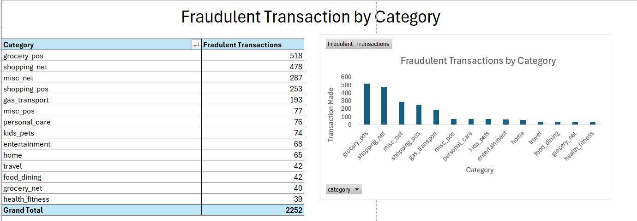

Key Findings
Category | Fraud Count
Grocery POS | 518
Shopping Net | 478
Misc Net | 287
Shopping POS | 253
Gas Transport | 193
The analysis indicates that Grocery POS and Shopping Net are the most vulnerable transaction categories, highlighting the need for stronger fraud detection mechanisms in these areas.

7. Average Transaction Amount by Job Role
Objective
To compare average transaction amounts across different occupations.
Analysis
A Pivot Table was created to calculate the average transaction amount for each customer occupation.

Job Type | Average Transaction Amount
Broadcast journalist | 1011.33
Ship broker | 972.11
Veterinary surgeon | 655.05
Industrial buyer | 654.49
Engineer, site | 638.91
Personnel officer | 638.58
Dancer | 586.45
Careers adviser | 531.47
Sales promotion account executive | 529.65
Air traffic controller | 503.75
Homeopath | 477.76
Armed forces technical officer | 351.60
Legal secretary | 292.42
Accountant, chartered | 282.58
Forest/woodland manager | 274.22
Solicitor | 152.26
Plant breeder/geneticist | 119.02
Minerals surveyor | 110.08
Clinical biochemist | 109.96
Chief of Staff | 109.34
Manufacturing systems engineer | 108.45
Osteopath | 107.87
Oceanographer | 106.24
Marketing executive | 104.30
Production assistant, television | 103.44
Outdoor activities/education manager | 103.41
Television/film/video producer | 102.71
Horticultural therapist | 102.41
Solicitor, Scotland | 101.93
Air broker | 99.68
Secretary/administrator | 99.54
Records manager | 99.10
Environmental health practitioner | 97.62
Merchandiser, retail | 97.30
Glass blower/designer | 97.24
Ambulance person | 97.10
Loss adjuster, chartered | 97.04
Immigration officer | 96.54
Garment/textile technologist | 96.53
Public house manager | 96.52
Cabin crew | 96.43
Pathologist | 96.43
Volunteer coordinator | 96.37
Animator | 95.93
Designer, interior/spatial | 95.58
Broadcast engineer | 95.54
Orthoptist | 95.06
Learning disability nurse | 94.89
Fisheries officer | 93.83
Dance movement psychotherapist | 93.71
Advertising account executive | 93.22
IT consultant | 93.03
Oncologist | 92.92
Gaffer | 92.54
Engineer, agricultural | 92.35
Teacher, English as a foreign language | 92.24
Field trials officer | 92.15
Toxicologist | 92.11
Pharmacist, hospital | 91.92
Music therapist | 91.70
Buyer, retail | 91.67
Administrator, local government | 91.11
Pharmacist, community | 90.98
Civil Service administrator | 90.95
Pharmacologist | 90.61
Community development worker | 90.57
Planning and development surveyor | 90.51
Training and development officer | 90.44
Chartered loss adjuster | 90.31
Communications engineer | 90.09
Petroleum engineer | 90.05
Tourist information centre manager | 90.00
Manufacturing engineer | 89.43
Electrical engineer | 88.32
Mental health nurse | 87.95
Arts development officer | 87.70
Restaurant manager, fast food | 87.61
Sports development officer | 87.50
Statistician | 87.46
Structural engineer | 87.45
Barrister's clerk | 87.39
Freight forwarder | 87.31
Radiographer, therapeutic | 87.13
Museum/gallery conservator | 86.94
Health physicist | 86.92
Geneticist, molecular | 86.90
Broadcast presenter | 86.79
Charity fundraiser | 86.52
Soil scientist | 86.44
Airline pilot | 86.41
Environmental education officer | 86.29
Leisure centre manager | 86.18
Clothing/textile technologist | 86.16
Intelligence analyst | 86.11
Trade mark attorney | 85.73
Surveyor, rural practice | 85.33
Land | 85.27
Civil engineer, contracting | 84.88
Logistics and distribution manager | 84.87
Dealer | 84.62
Designer, furniture | 84.57
Geologist, engineering | 84.47
Transport planner | 84.44
Contractor | 84.15
Theatre manager | 84.10
Farm manager | 84.08
Designer, exhibition/display | 83.66
Designer, industrial/product | 83.31
Agricultural consultant | 83.17
Chartered accountant | 83.15
Environmental manager | 83.09
Commercial horticulturist | 83.05
Writer | 82.92
Librarian, public | 82.88
Air cabin crew | 82.87
Trading standards officer | 82.62
Administrator | 82.60
Aeronautical engineer | 82.50
Dispensing optician | 82.38
Bookseller | 82.01
Lawyer | 81.86
Phytotherapist | 81.75
Museum/gallery exhibitions officer | 81.75
Administrator, arts | 81.44
Pilot, airline | 81.02
Administrator, charities/voluntary organisations | 80.89
Economist | 80.44
Geophysicist/field seismologist | 80.36
Fine artist | 80.18
Academic librarian | 79.91
Administrator, education | 79.83
Medical technical officer | 79.79
Sports administrator | 79.64
Artist | 79.47
Chemical engineer | 79.14
Podiatrist | 79.08
Theme park manager | 78.84
Sales executive | 78.69
Film/video editor | 78.60
Investment banker, corporate | 78.57
Learning mentor | 78.41
Commercial/residential surveyor | 77.70
Psychologist, counselling | 77.55
English as a second language teacher | 77.46
Television floor manager | 77.40
Radio broadcast assistant | 77.39
Sub | 77.26
Occupational psychologist | 77.25
Teacher, early years/pre | 77.24
Arboriculturist | 77.19
Occupational hygienist | 77.02
Careers information officer | 76.94
Teacher, secondary school | 76.63
Police officer | 76.59
Editor, magazine features | 76.44
Furniture designer | 76.37
Psychologist, forensic | 76.34
Engineer, building services | 76.34
Presenter, broadcasting | 76.28
Development worker, community | 75.83
Human resources officer | 75.70
Physiotherapist | 75.65
Education administrator | 75.54
Accounting technician | 75.46
Medical sales representative | 75.41
Naval architect | 75.38
Horticulturist, commercial | 75.32
Mudlogger | 75.21
Primary school teacher | 74.96
Technical brewer | 74.83
Politician's assistant | 74.82
Systems developer | 74.80
Environmental consultant | 74.72
Health service manager | 74.47
Conservator, museum/gallery | 74.32
Therapist, horticultural | 74.21
Purchasing manager | 74.19
Call centre manager | 74.12
Operational researcher | 73.82
Scientist, audiological | 73.76
Chief Financial Officer | 73.72
Surveyor, land/geomatics | 73.63
Hospital pharmacist | 73.47
Scientist, marine | 73.43
Radiographer, diagnostic | 72.95
Accountant, chartered certified | 72.89
Prison officer | 72.83
Science writer | 72.62
Programmer, applications | 72.51
Clinical research associate | 72.46
Engineer, control and instrumentation | 72.41
Firefighter | 72.38
Sales professional, IT | 72.34
Private music teacher | 72.31
Production engineer | 72.23
Hydrologist | 72.23
Health and safety adviser | 72.21
Conservation officer, historic buildings | 72.12
IT trainer | 72.06
Mechanical engineer | 71.77
Public relations account executive | 71.31
Nurse, children's | 71.26
Health visitor | 71.18
Retail buyer | 71.15
Research scientist (medical) | 71.11
Engineer, biomedical | 71.04
Buyer, industrial | 70.96
Scientific laboratory technician | 70.96
Data scientist | 70.76
Exhibition designer | 70.74
Health promotion specialist | 70.70
Designer, ceramics/pottery | 70.64
Advice worker | 70.60
Higher education careers adviser | 70.38
Theatre director | 70.23
TEFL teacher | 70.16
Medical physicist | 70.06
Analytical chemist | 70.04
Biochemist, clinical | 70.02
Wellsite geologist | 70.01
Race relations officer | 69.99
Chief Strategy Officer | 69.98
Education officer, community | 69.97
Production manager | 69.88
Interpreter | 69.86
Information systems manager | 69.75
Equities trader | 69.74
Water engineer | 69.62
Textile designer | 69.53
Paramedic | 69.36
Musician | 69.33
Multimedia programmer | 69.29
Engineer, aeronautical | 69.14
Chiropodist | 69.13
Press photographer | 69.07
Education officer, museum | 69.06
Equality and diversity officer | 68.95
Media buyer | 68.94
Engineer, production | 68.92
Geologist, wellsite | 68.86
Journalist, newspaper | 68.78
Network engineer | 68.66
Jewellery designer | 68.53
Psychologist, sport and exercise | 68.53
Ceramics designer | 68.50
Animal nutritionist | 68.43
Editor, film/video | 68.43
Designer, textile | 68.41
Civil Service fast streamer | 68.39
Geochemist | 68.37
Nature conservation officer | 68.37
Therapist, drama | 68.32
Facilities manager | 68.30
Scientist, biomedical | 68.27
Systems analyst | 68.26
Company secretary | 68.25
Senior tax professional/tax inspector | 68.22
General practice doctor | 68.13
Chief Executive Officer | 67.99
Landscape architect | 67.97
Engineer, mining | 67.95
Stage manager | 67.91
Archivist | 67.87
Engineer, structural | 67.82
Engineer, civil (contracting) | 67.77
Event organiser | 67.75
Control and instrumentation engineer | 67.74
Metallurgist | 67.61
Insurance broker | 67.43
English as a foreign language teacher | 67.41
Doctor, general practice | 67.39
Early years teacher | 67.36
Land/geomatics surveyor | 67.17
Pensions consultant | 67.09
Financial trader | 67.05
Audiological scientist | 67.03
Teacher, special educational needs | 67.01
Management consultant | 66.96
Community pharmacist | 66.89
Comptroller | 66.83
Commissioning editor | 66.81
Designer, multimedia | 66.79
Programmer, multimedia | 66.66
Forensic psychologist | 66.59
Futures trader | 66.58
Architect | 66.54
Site engineer | 66.49
Catering manager | 66.39
Art gallery manager | 66.35
Energy manager | 66.27
Scientist, physiological | 66.21
Engineer, maintenance | 66.14
Advertising copywriter | 66.09
Engineer, materials | 66.06
Librarian, academic | 66.05
Associate Professor | 66.00
Cytogeneticist | 65.93
Magazine journalist | 65.87
Chemist, analytical | 65.85
Acupuncturist | 65.74
Television production assistant | 65.73
Set designer | 65.72
Chief Technology Officer | 65.61
Waste management officer | 65.44
Quantity surveyor | 65.42
Teacher, adult education | 65.42
Investment analyst | 65.32
Cartographer | 65.31
Engineer, civil (consulting) | 65.27
Engineer, automotive | 65.20
Copywriter, advertising | 65.16
Engineer, petroleum | 65.13
Psychotherapist, child | 65.12
Retail banker | 64.92
Educational psychologist | 64.84
Engineering geologist | 64.82
Radio producer | 64.77
Community education officer | 64.64
Research officer, political party | 64.63
Psychologist, clinical | 64.61
Risk analyst | 64.60
Product manager | 64.59
Building control surveyor | 64.53
Surveyor, minerals | 64.47
Public affairs consultant | 64.46
Heritage manager | 64.46
Armed forces training and education officer | 64.39
Exhibitions officer, museum/gallery | 64.38
Diagnostic radiographer | 64.36
Surgeon | 64.32
Town planner | 64.31
Database administrator | 64.28
Nurse, mental health | 64.24
Archaeologist | 64.15
Web designer | 64.01
Make | 63.97
Conservator, furniture | 63.96
Maintenance engineer | 63.81
Lexicographer | 63.65
Scientist, research (medical) | 63.57
Applications developer | 63.54
Research scientist (physical sciences) | 63.50
Engineer, land | 63.49
Fitness centre manager | 63.32
Insurance risk surveyor | 63.07
Production assistant, radio | 63.01
Historic buildings inspector/conservation officer | 62.95
Development worker, international aid | 62.93
Telecommunications researcher | 62.92
Occupational therapist | 62.82
Building surveyor | 62.77
Teacher, primary school | 62.60
Optician, dispensing | 62.58
Research officer, trade union | 62.52
Visual merchandiser | 62.45
Water quality scientist | 62.34
Quarry manager | 62.29
Emergency planning/management officer | 62.12
Optometrist | 62.00
Horticultural consultant | 61.84
Armed forces logistics/support/administrative officer | 61.78
Insurance claims handler | 61.78
Operations geologist | 61.73
Counsellor | 61.61
Chief Operating Officer | 61.51
Charity officer | 61.50
Physicist, medical | 61.48
Exercise physiologist | 61.47
Social research officer, government | 61.45
Chartered public finance accountant | 61.42
Energy engineer | 61.39
Psychiatrist | 61.38
Corporate investment banker | 61.31
Estate manager/land agent | 61.29
Child psychotherapist | 61.24
Clinical cytogeneticist | 61.22
Field seismologist | 61.10
Building services engineer | 61.07
Advertising account planner | 61.06
Music tutor | 61.05
Producer, radio | 61.04
Curator | 61.02
Pension scheme manager | 61.02
Camera operator | 60.98
Chief Marketing Officer | 60.95
Producer, television/film/video | 60.89
Hydrogeologist | 60.87
Aid worker | 60.85
Scientist, clinical (histocompatibility and immunogenetics) | 60.85
Claims inspector/assessor | 60.78
Lecturer, higher education | 60.76
Physiological scientist | 60.75
Herbalist | 60.71
Community arts worker | 60.69
Warden/ranger | 60.59
Programme researcher, broadcasting/film/video | 60.45
Editor, commissioning | 60.37
Sport and exercise psychologist | 60.37
Copy | 60.28
Patent attorney | 60.27
Teaching laboratory technician | 60.23
Licensed conveyancer | 60.12
Doctor, hospital | 60.01
Further education lecturer | 59.91
Surveyor, mining | 59.90
Tax adviser | 59.87
Designer, jewellery | 59.74
Interior and spatial designer | 59.72
Insurance underwriter | 59.72
Designer, television/film set | 59.71
Market researcher | 59.70
Rural practice surveyor | 59.53
Secondary school teacher | 59.52
Museum education officer | 59.41
Ecologist | 59.38
Magazine features editor | 59.30
Counselling psychologist | 59.29
Professor Emeritus | 59.14
Mining engineer | 59.13
Medical secretary | 59.12
Barista | 59.11
Drilling engineer | 59.07
Tax inspector | 59.03
Paediatric nurse | 59.02
Financial adviser | 58.81
Retail manager | 58.79
Television camera operator | 58.62
Therapist, occupational | 58.52
Product designer | 58.52
Chartered legal executive (England and Wales) | 58.48
Materials engineer | 58.34
Regulatory affairs officer | 58.26
Video editor | 58.23
Amenity horticulturist | 58.23
Herpetologist | 58.17
Biomedical scientist | 58.08
Engineer, technical sales | 58.08
Social researcher | 57.88
Special effects artist | 57.88
Therapist, art | 57.87
Barrister | 57.78
Surveyor, hydrographic | 57.77
Industrial/product designer | 57.64
Engineer, drilling | 57.63
Engineer, manufacturing | 57.62
Therapist, music | 57.58
Research scientist (maths) | 57.53
Tree surgeon | 57.45
Colour technologist | 57.29
Lecturer, further education | 57.19
Art therapist | 57.17
Illustrator | 56.72
Immunologist | 56.66
Investment banker, operational | 56.35
Neurosurgeon | 56.19
Biomedical engineer | 56.02
Accountant, chartered public finance | 55.97
Tourism officer | 55.87
Geoscientist | 55.46
Local government officer | 54.94
Public relations officer | 54.90
Media planner | 54.84
Engineer, broadcasting (operations) | 54.47
Probation officer | 54.44
Embryologist, clinical | 54.42
Hotel manager | 54.37
Psychiatric nurse | 54.37
Public librarian | 54.13
Location manager | 54.11
Retail merchandiser | 54.03
Nutritional therapist | 53.86
Animal technologist | 53.67
Hospital doctor | 53.42
Special educational needs teacher | 53.37
Engineer, electronics | 53.28
Hydrographic surveyor | 53.22
Product/process development scientist | 52.39
Electronics engineer | 52.33
Scientist, research (maths) | 51.73
Press sub | 51.66
Tour manager | 50.91
Architectural technologist | 50.78
Psychotherapist | 49.78
Travel agency manager | 49.58
Scientist, research (physical sciences) | 49.45
Furniture conservator/restorer | 48.88
Seismic interpreter | 48.53
Clinical psychologist | 47.97
Research scientist (life sciences) | 45.66
Therapist, sports | 44.17
Engineer, communications | 42.80
Information officer | 39.25
Grand Total | 70.442

Key Findings
- Certain occupations, such as Broadcast Journalist and Ship Broker, recorded the highest average transaction amounts.
- The variation in transaction amounts across occupations suggests that spending behavior differs among customer professions.
- This information may assist in customer segmentation and behavioral analysis.

Overall Excel Conclusion
The Excel analysis provided valuable insights into customer transactions and fraud patterns. The data revealed a highly skewed distribution of transaction amounts with significant outliers, indicating the presence of unusually high-value transactions. Fraud was found to be concentrated primarily in Grocery POS and Shopping Net categories, while customer gender showed minimal influence on fraudulent activity. Additionally, Texas, New York, and Pennsylvania generated the highest transaction volumes. Correlation analysis confirmed that city population has virtually no relationship with transaction amount, suggesting that transaction behavior is independent of city size. These findings establish a strong foundation for further analysis using SQL, Python, and Tableau to develop a comprehensive fraud detection solution.

